LABCOL-2293

Building Webex Teams bots using business logic templates

**Alexey Sazhin**, Technical Leader, CX

**Sergey Sazhin**, Security Technical Leader, CX

**Vladimir Savostin**, Technical Leader, CX

Introduction or Learning Objectives

Upon completion of this lab, you will get practical experience working with interface of Webex Teams bots, while hiding complexity and concentrating on business logic. The lab contains tasks of different complexity, you can focus on different levels: basic and intermediate, based on the level of your previous experience with Webex Teams bots.

Doing this lab, you will build and run a Webex Teams bot for one of the business process types:

* Sample bot (***‘whoami’*** and ***‘echo’*** use cases).
* TAC Self Service (gathering defect details).

During the lab you will:

* Learn bot’s capabilities in Webex Teams
* Use Python Webexteams SDK API calls to register the bot with Webex Teams
* Get familiar with business logic templates to use them for future projects

In this lab, you will be presented with the platform, tools and components to build the bots in Webex Teams. You will also be shown how to use business logic templates to run different automation workloads on top of platform integration. You will also get references regarding platform design decisions and how to solve the most usual problems. You will also learn how to run automation of business processes using bots interface.

Disclaimer

This training document is to familiarize with creating bots for Webex Teams platform. Although the lab design and configuration examples could be used as a reference, it’s not a real design, thus not all recommended features are used, or enabled optimally. For the design related questions please contact your representative at Cisco, or a Cisco partner.

Table of contents

Introduction Or Learning Objectives 2

Disclaimer 2

Table of contents 3

Get started 4

Step 1 Get access details from Webex Teams bot 4

Step 2 Anyconnect VPN establishment 5

Step 3 RDP connection 5

Scenario 6

1. Bot’s integration with external entities 9

2. Bot’s integration with Webex Teams clients 9

3. Main tools to make Webex Teams bots running 10

a. Flask 10

b. Ngrok 10

4. Notes: 10

5. Links to the LABCOL-2293 Project on GitHub: 10

Option #1: Become Webex Teams user 11

1.1 Add yourself to the Webex Teams bot 11

1.2 Get information about defects from Webex Teams bot 12

1.3 See how the bots are created 12

Option #2: Become Webex Teams bot’s developer (intermediate) 23

a. Write sample bot 23

b. Create Cisco Support API bot (defect’s information) 37

Summary 48

Links to the LABCOL-2293 Project on GitHub 49

Related Sessions at Ciscolive 50

List of Acronyms 51

Get started

1. Get access details from Webex Teams bot

Bot’s access token along with Anyconnect credentials to be collected from a Webex Teams bot (**PinaColada@sparkbot.io**):

1. Login to Webex Teams using your (existing) account credentials in Webex Teams web application.

If you don’t have existing Webex Teams account, use credentails from your lab access ticket.

1. In a Webex Teams, add the following bot:

**pinacolada@sparkbot.io**

Use search field **(1)** and start conversation with a bot **(2)**:

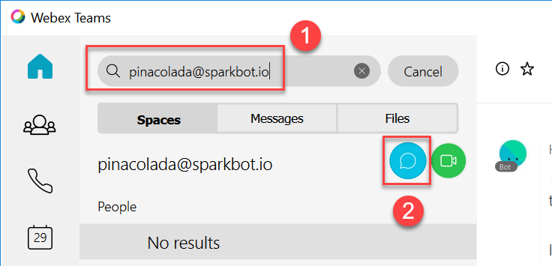

1. Start a room space with the bot and type the following command to get your credentials (сheck your lab ticket to get an <access hash> for your pod):

**/accesslab <access hash>**

For each Bot access token, **PinaColada** bot sends username of the respective bot (for testing purposes, when Python script with bot's code is running).

1. Anyconnect VPN establishment

Please connect to the lab with **Cisco AnyConnect** :

1. Start **Cisco AnyConnect** on your laptop.
2. Copy the **Host** URL from the **AnyConnect Credentials** (sent by **PinaColada**) and then paste it in the **URL Connection box** in the **AnyConnect** login window.
3. Click **Connect**.  
   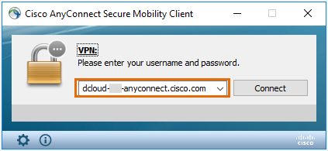
4. Copy a User ID and the password from the **AnyConnect Credentials** and then paste each into the **Cisco AnyConnect** login window.
5. Click **OK**.
6. Click **Accept** on the window confirming your connection.
7. When connected to your AnyConnect VPN session, the AnyConnect VPN icon is displayed in the system tray.
8. To view connection details or to disconnect, click the AnyConnect VPN icon and then choose **Disconnect**.
9. RDP connection
10. Copy RDP connection details from **PinaColada@sparkbot.io**.
11. Establish RDP connection, using Microsoft Remote Dektop Client[1].

Scenario

Disclaimer:

This is a work of fiction. Names, characters, businesses, places, events, locales, and incidents are either the products of the author’s imagination or used in a fictitious manner. Any resemblance to actual persons, living or dead, or actual events is purely coincidental. But it’s based on a true story.

**Imagine the following situation is happening:**

There are many routine information that you need to collect from the devices. Your department is understaffed and even despite of you’ve being working only with collaboration products for many years (congratulations, you are Collaboration SME!), your manager asks you to prepare different reports by yourself. You know, your network is comprised of many different technologies:

1. Routing & Switching
2. Security
3. Wi-Fi
4. Collaboration

From one of the Cisco trainings, you remember there is ability in Cisco Webex Teams bots for the integration with Cisco Support APIs to get information about defects, EoX and inventory information from the equipment.

**In the current lab, you have three options (see Get started):**

1. Option #1 – Learn how interact with bots in Webex Teams and get needed information (tech level – basic, if you are not feeling yourself ready to become a programmer).
2. Option #2 – Write the Webex Teams bot, integrate it with Cisco API and give it to your support desk so they can find defects information quickly by themselves. Write the Webex Teams bot to perform quiz for technical interviews (tech level - intermediate).
3. Option #3 – Write advanced Webex Teams bot, using advanced integration capabilities. (tech level - advanced).



**Figure 1 – High-Level overview of the lab tasks**

**High-Level Lab Topoogy**



**Figure 2 ̶** **High-level Lab Topology**

Above is the lab’s topology. The central part of lab is Cisco Webex Teams bot, which is to be written on Python. Below is high-level information about topology of the lab, please, read it carefully before start doing the lab.

Bots are similar to regular Webex Teams users. They can participate in 1-to-1 and group spaces and users can message them directly or add them to a group space. A special badge is added to a bot's avatar in the Webex Teams clients so users know they're interacting with a bot instead of a human.

A bot can only access messages sent to it directly. In group spaces, bots must be [@mentioned](https://collaborationhelp.cisco.com/article/en-us/p5k20o) to access the message. In 1-to-1 spaces, a bot has access to all messages from the user.

Bots do not, however, perform actions within Webex Teams on behalf of a Webex Teams user. If you're creating an application that needs to participate in Webex Teams and perform actions with a user's account, check out [Integrations](https://developer.webex.com/docs/integrations).

1. Bot’s integration with external entities

Depending on the path selected and chosen task, it will communicate with the following external entities:

1. Data Sources:

* PostgreSQL
* MongoDB
* Text files in JSON format

1. Gmail (via SMTP).
2. Bot’s integration with Webex Teams clients

In every task of the lab, a bot would be communicating with a Webex Teams client (in the course of this lab, web-based client of Webex Teams is used).

A bot can’t communicate directly with Webex Teams clients, but does it via Webex Teams Cloud.

Communication is established in the following way:

1. In order to deliver messages, bot sends HTTP POST to a client – directly through Webex Teams Cloud.
2. In order to get messages from a client – bot is programmed to listen to Webhook from Webex Teams Cloud. Each time Webex Teams Cloud detect message from a client – it notifies a bot using Webhook (using HTTP POST).

JSON is used as format of sending data between Python bot and Webex Teams Cloud.

1. Main tools to make Webex Teams bots running
   1. Flask

In order to be able to receive Webhooks from Webex Teams Cloud, a bot must be integrated with Web Server. In a course of the lab, [Flask](http://flask.pocoo.org/), an easy and powerfool framework would be used to run a web server on Python.

* 1. Ngrok

Since a bot is running on a server which isn’t reachable from the Internet, [Ngrok software](https://ngrok.com/) is used to host Public URLs using which bot’s web server could be reachable (for building webhook integration).

1. Notes:

* In the lab, client and server, while a logically separate entities in a drawing above, are physically hosted on the same machine.
* All script for bots are tested on Python 3.7.2 but should also work on another Python 3 releases.
* Cisco Webex Teams client exists in agent and agentless (web-based) form-factors. Throughout this lab web-based client would be used.

1. Links to the LABCOL-2293 Project on GitHub:

**URL to Clone or download:** <https://github.com/cleur2293/labcol.git>

**URL to open in a browser:** <https://github.com/cleur2293/labcol>

Up to date version of the code and lab guide are always available using these links. Fill free to use it in your Projects.

Option #1: Become Webex Teams user

Technical level of this task: **basic**

**Option #1 Steps (Use TAC Self Service bot to get bug details):**

* Add yourself to the existing Webex Teams bot.
* Get information about Cisco bugs to tackle them in your network (Cisco Support API bot is used, which is developed in Task 2.b).
* Create and run sample bot (shows information about your Webex Teams account and echoes back received messages)
  1. Add yourself to the Webex Teams bot

Cisco Webex Teams client exists in agent and agentless (web-based) form-factors. Throughout this lab web-based client would be used.

1. Use the following link to open a web-based Webex Teams client:

[https://teams.webex.com/](https://teams.webex.com/spaces)

1. Enter email address[2], press Next
2. Enter password2 and press **Sign In** button.
3. On the left corner in a Search tab, input name of Service Webex Teams Bot:

**CL20B_LABCOL2293_SERVICE@webex.bot (see Figure 3)**

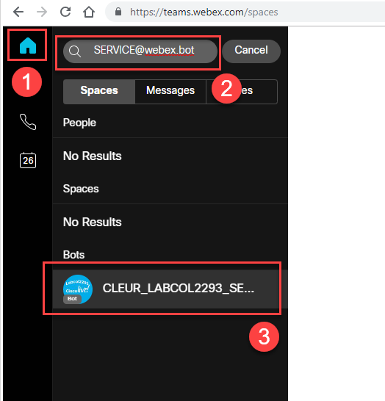

**Figure 3 ̶ Find a service bot (CLEUR_LABCOL2293_SERVICE@webex.bot)**

1.2 Get information about defects from Webex Teams bot

1. Webex Teams space would be created, so that you can chat with a bot.
2. Start putting bug ids into a chat box in a space with a bot (see **Figure 4**).

**/bug <bug_id>**

You can user the following bug ids to test bot’s functionality:

/bug CSCdr72939

/bug CSCvb57414

/bug CSCuz44968

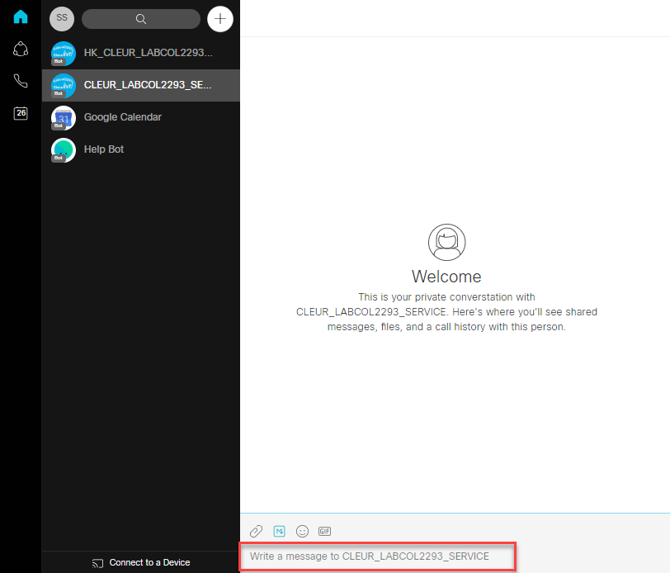

**Figure 4 ̶ Chat with a service bot**

1.3 See how the bots are created

Create, start your own bot and interact with it in Webex Teams client.

All script for bots in this lab are written on Python 3[3].

1. Create new bot on Webex Teams website.
2. Create a [Webhook](https://developer.webex.com/docs/api/guides/webhooks) (so that a bot could listen to the messages from Webex Clients).
3. Copy code of sample bot from GitHub.
4. Replace Bot's Access Token in a configuration file.
5. Start Ngrok.
6. Start Bot (Python script).
7. Open Webex Teams client and start chatting with basic bot.
8. Create a bot on Webex Teams

Creating bot is a two steps process:

* Create a “user” account on Webex Teams, using Webex for Developers.
* Create a program that provides the brains behind the created account.

1. Login to the following URL to create a new bot:

<https://developer.webex.com/login>

1. On the opened window:

Enter email address[4]

Enter password4 and press **Sign In** button.

1. On the opened window:

Press **Start Building Apps** button

1. On the opened window:

Press **Create A New App** button

1. On the opened window:

Press **Create a Bot** button

1. On the opened window fill in all the fields:

**Bot Name, Bot Username: CLEUR_LABCOL2293_<random 3-digits number>**

Bot’s username must but unique. If you get an error, stating: **“<bot’s name> bot is not available**”, please change random 3-digits number in a Bot’s username to another value and try again. It’s also advisable to change Bot’s Name to the same value for consistency.

**Icon:** Choose one of the default

**Description: CLEUR_LABCOL2293 basic bot test**

1. Press **Add Bot** button
2. On the opened window:

Copy **Bot’s Access Token** (see **Figure 5**), save it in a Windows notepad application.

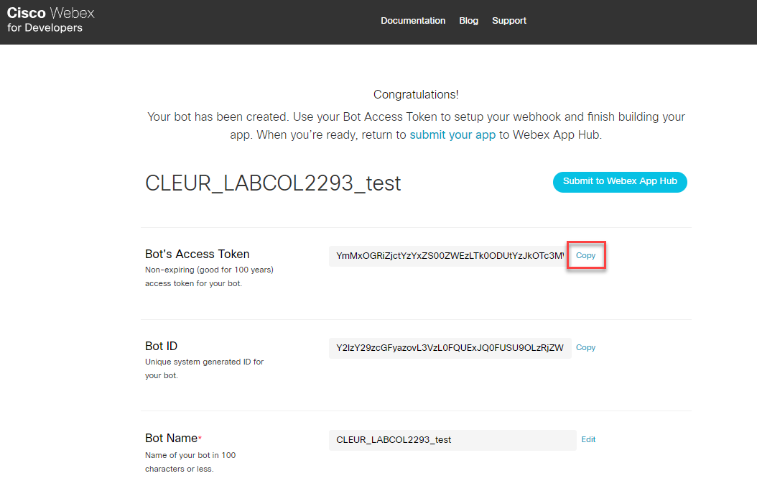

**Figure 5 ̶ Copy bot’s access token**

1. Start Ngrok

Click **ngrok-start.bat** on a Desktop (see **Figure 6**)

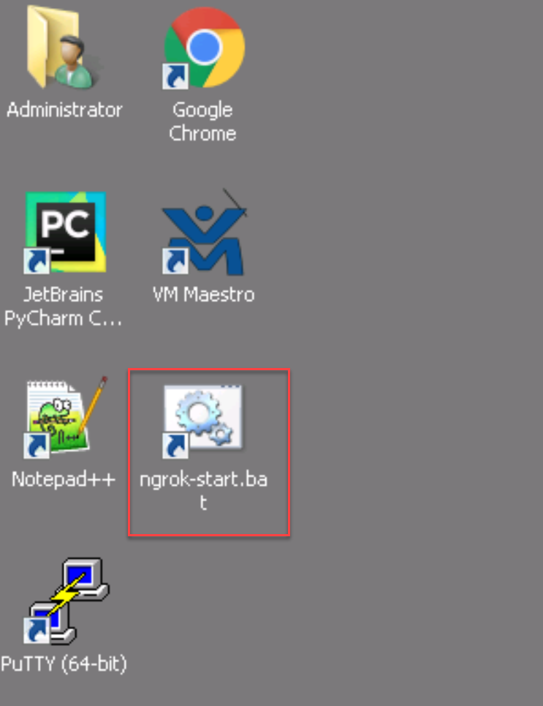

**Figure 6 ̶ Run ngrok-start.bat**

Windows command line would be opened, Ngrok will start and print out the information. Copy http “forwarding” URL (see **Figure 7**). All requests (in case of Webex Teams) coming to this URL would be forwarded to **localhost:5000** (Flask web server would be listening on this socket). Copy this URL, which would be required to create a Webhook.

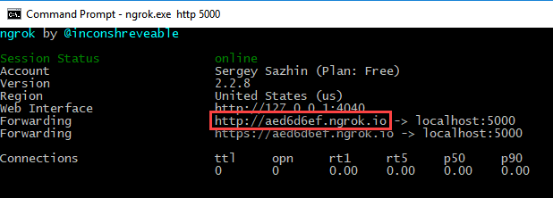

**Figure 7 ̶ Copy http “forwarding” URL**

1. Create a Webhook

In order to make a bot listen to the messages sent by Webex Clients, [Webhooks](https://developer.webex.com/docs/api/guides/webhooks) should be used:

<https://developer.webex.com/docs/api/v1/webhooks/create-a-webhook>

For each bot separate Webhook needs to be created. In another parts of the lab Webhooks are created automatically by script (based on forwarding URL created by Ngrok) via Ngrok API.

On the opened window fill in the fields in accordance with stated below, use Figure 8 for the guidance:

1. Authorization – **disable**
2. Bearer: <**Bot’s Access Token, copied before (see Figure 5)>**
3. Name: **CLEUR_LABCOL2293_test_bot**
4. TargetURL: <**“forwarding” URL from the previous step (from Ngrok)>/events[5]**
5. Resource: **messages**
6. Event: **created**
7. Press **Run** button

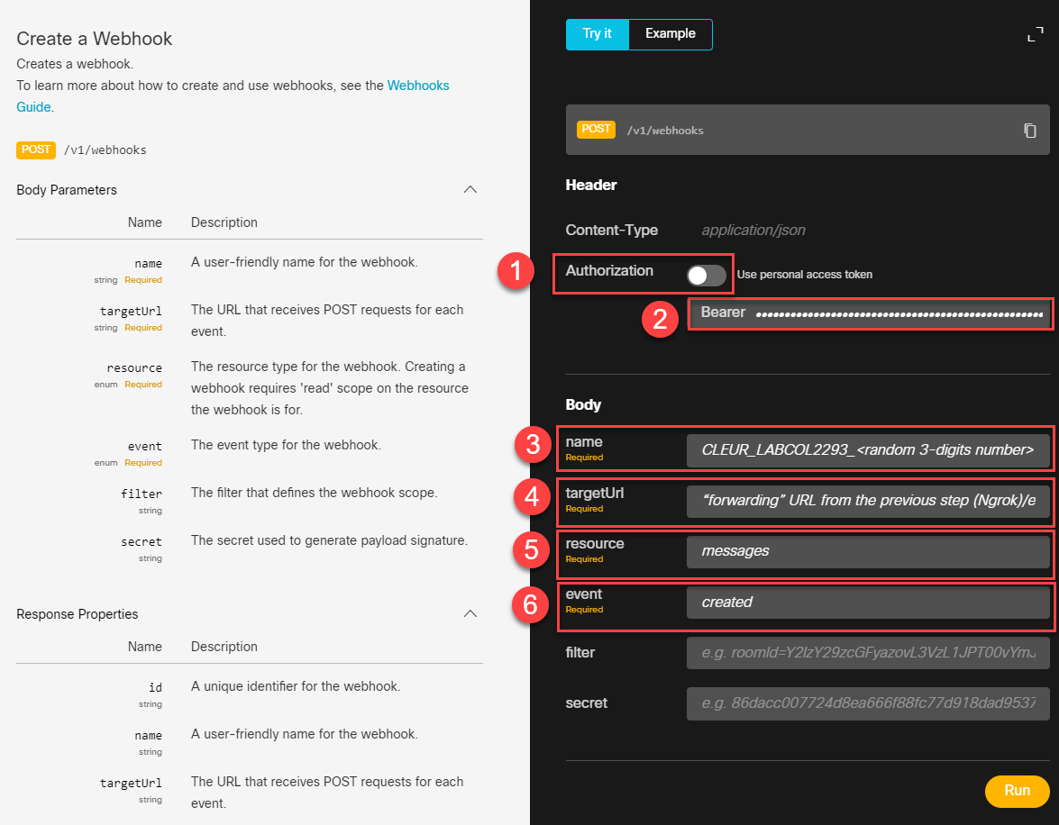

**Figure 8 ̶ Creating a webhook manually**

1. Below the **Run** button on this page, response with the details of created Webhook will show up. Copy the id of Webhook to use it further in this task (see Figure 9).

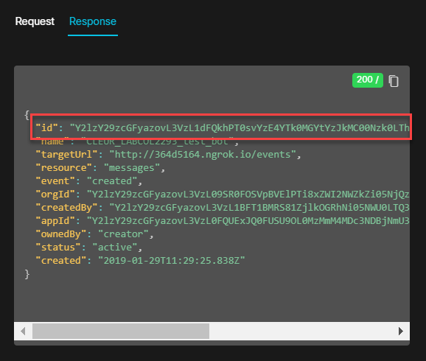

**Figure 9 ̶ Response with details of created Webhook**

1. Manual test of Webhook

Manual test of Webhook is required because in further Steps the bot’s code generates Webhook automatically. For the sake of simplicity, we are testing created Webhook here so that you get an understanding how Webhook works.

1. Open a Web Browser with Webex Teams web-client, add the bot with a name chosen before: **CLEUR_LABCOL2293_<random 3-digits number>@webex.bot**.
2. Send any text to the bot to test Webhook works correctly.
3. Open a management interface of **Ngrok** and look for the HTTP POST messages that **Ngrok** receives:

<http://127.0.0.1:4040/inspect/http>

1. Ensure “id” of Webhook received in HTTP POST is the same as copied in step 8 before (see “1” on **Figure 10**).
2. Check attributes of Webhook in HTTP POST (see “2”).
3. HTTP “Bad Gateway” server error is expected in this task, because Flask Web Server is not running (see “3”).

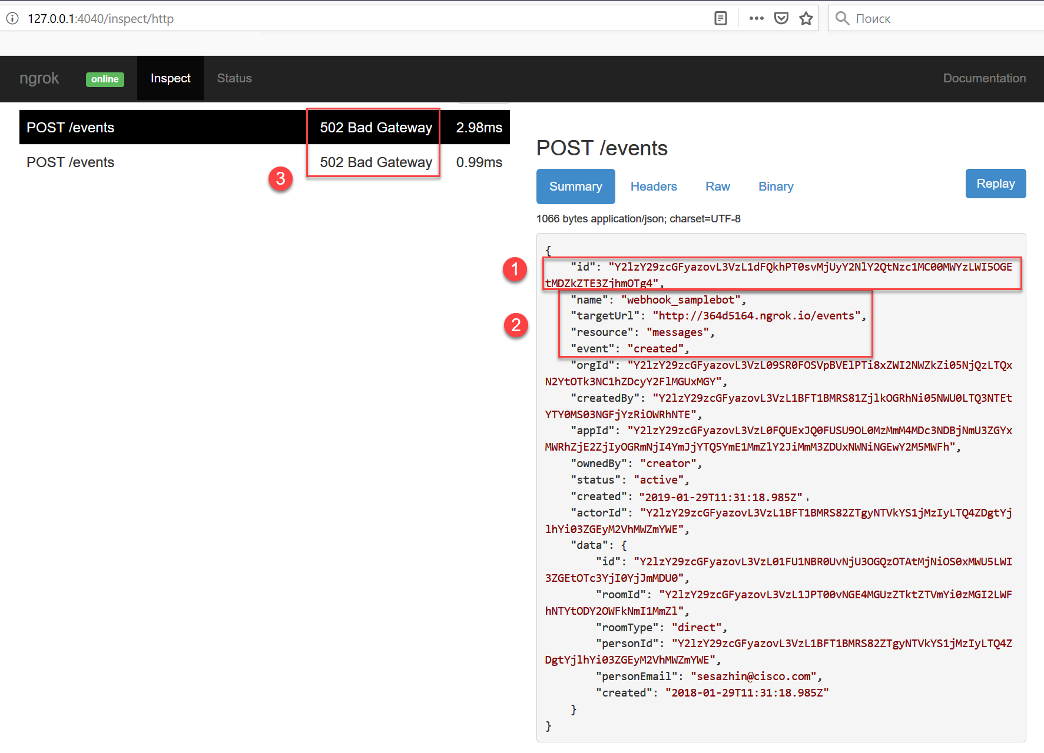

**Figure 10 ̶ Contents of HTTP POST on Ngok**

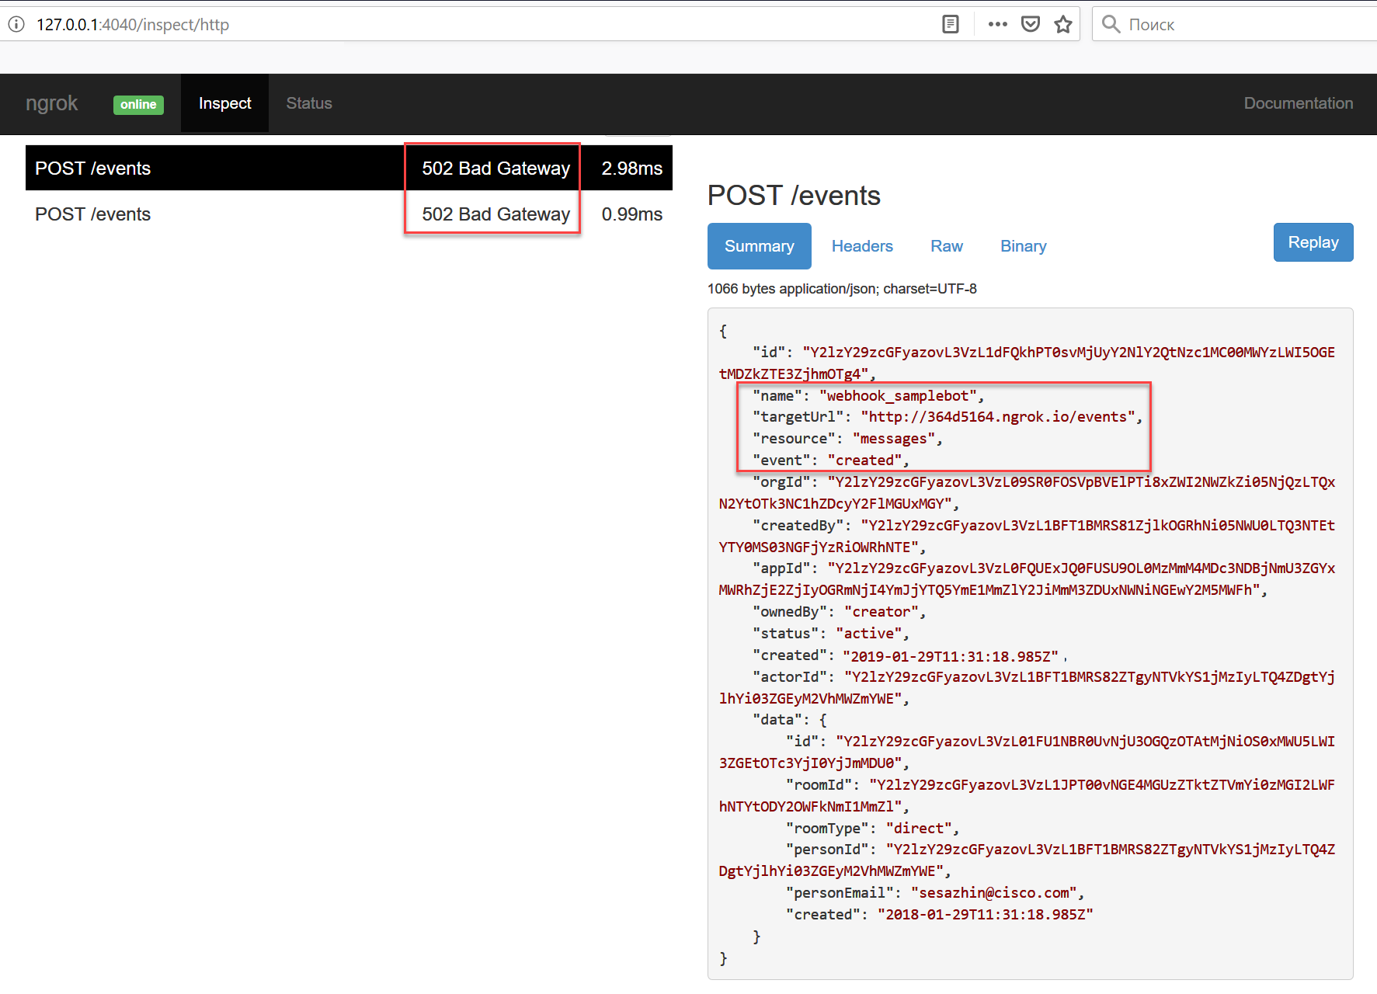

**Figure 11 ̶ Creating a webhook manually**

1. Copy code of sample bot from GitHub

Click “JetBrains PyCharm Community Edition 2019.3.1 x64” on a Desktop to run a PyCharm (IDE for Python)

Go to: **VCS -> Get from Version Control**

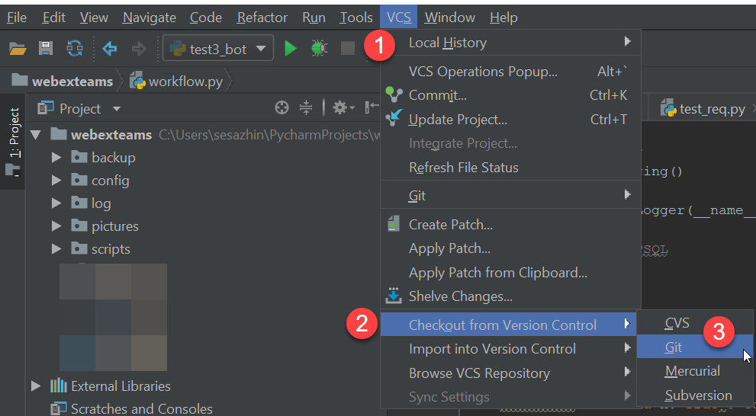

**Figure 12 ̶ Checkout from Git repository**

On the opened Windows use the following data to fill (see Figure 13):

**URL: https://github.com/cleur2293/labcol.git**

Press **Clone** button

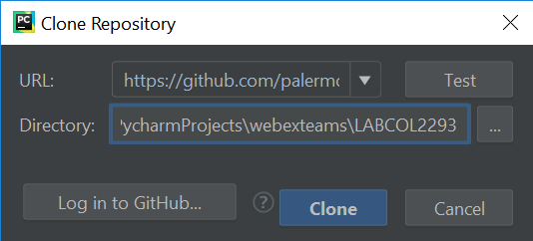

**Figure 13 ̶ Clone Repository Window**

On the opened Window press **Yes** to open the project checked out from GitHub:

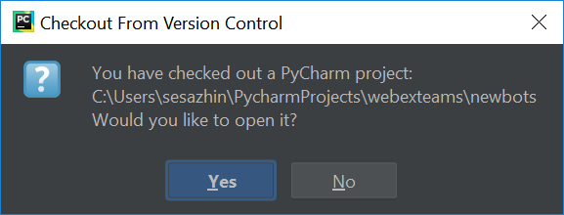

**Figure 14 ̶ Chekout from Version Control Window**

On the opened Window press **This Window** to opened the project in the same window in PyCharm:

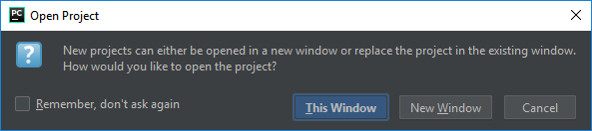

**Figure 15 ̶ Open Project Window**

1. Replace Bot's Access Token in a configuration of a bot

In a PyCharm, open a script with a bot:

**main > bot_sample > bot.py**

After **bot_access_token:** in a Python code, put **Bot’s Access Token[6]** copied in Step 1 above (place it between quotes).

1. Start Bot (Python script)

While **bot.py** is opened in PyCharm, press **CTRL + Shift + F10** to start the bot.

1. Open Webex Teams client and start chatting with a basic bot
2. Open a Web Browser with Webex Teams web-client, add the bot with a name chosen before: **CLEUR_LABCOL2293_<random 3-digits number>@webex.bot**
3. In the created Webex Teams space, start chatting with a bot.

The following actions supported:

* **/whoami** – command that will instruct the bot to show information about your account in Webex Teams.
* If you input **/echo** followed with some phrase, the bot echoes the phrase back in the same Webex Teams room.

Option #2: Become Webex Teams bot’s developer (intermediate)

Technical level of this task: **intermediate**

**Option #2 Steps:**

* 1. Write sample bot.
  2. Create Cisco Support API bot (defect’s information)
  3. Create the Webex Teams bot to perform quiz for technical interviews (not available in the lab yet)

You want to get rid of the work related to the technologies you are not fun of, you want to write the bot to integrate it with Cisco API and give it to your support desk, so they find and fix all technical issues. But for now you think you should get more experience with Webex Teams bots before you start writing the bot for integration with Cisco external API.

To prove your colleagues you can write a Webex Team bot, you decided to show them a “quick win” and write a sample bot.

This will increase your vilibility inside the company, so that your manager and peers now you can use Webex Teams bots to solve current challenges in the innovative way.

* 1. Write sample bot

As the first task in your bot’s developer journey, you will write a sample bot, which supports the following tasks:

* If a user chatting with a bot inputs **/whoami** command, a bot will show an information about user’s account in Webex Teams.
* If a users chatting with a bot inputs any phrase, bot echoes it back in the same Webex Teams room

For this task a bot has been pre-created in Webex Teams cloud, you will need Bot access token to make your bot script able to receive and write messages on behalf of the Bot.

A Webex Teams Access Token is how the Webex Teams APIs validate access and identify of the requesting user (bot).

You have already got your bot’s access token along with your Anyconnect credentials from **PinaColada** Webex Teams bot (see Get started Chapter).

You can also follow a chapter **“Create a bot on Webex Teams.”** of this lab guide to check out the process of creating a new Webex Teams bot in Webex Teams cloud.

We are going to use webexteamssdk to send API calls to the Webex Teams Cloud.

When you create a webhook for a particular event, the notification data will be sent as an HTTP POST, in JSON format, to a URL of your choosing, each time it is triggered.

The following solution components to be used as part of this task (see **Figure 16**):

1. Github (PyCharm would be used just to pull Python and configuration files of Webex Teams bots).
2. Flask Web Servrer.
3. Ngrok.
4. Webex Teams client (web-based).
5. Webex Teams cloud.



**Figure 16 ̶ Solution components of sample bot**

To complete this task, the following steps to be followed:

1. Pull Webex Teams bot’s code from GitHub (See Chapter “Copy code of sample bot from GitHub” from Option #1 for the details).
2. Prepare and test Python code to run Flask server (to later get Webhooks from Webex Teams Cloud).
3. Start Ngrok application.
4. Prepare and test Python code to create a Webhook, pointing to forwarding URL created by Ngrok application.
5. Add Webex Teams bot’s logic to Python code
6. Run Sample Bot

Because in this task only sample bot is covered, with a simple logic, the Python code would be written in one Python file. You will see example of distribution of the bot’s Python code to the different files in the next tasks where the logic behind bot is more sophisticated.

1. Pull Webex Teams bot’s code from GitHub

See Chapter “Copy code of sample bot from GitHub” for the details.

After copying of the code from GitHub is completed, you will see a project’s structure in a Project’s tab on the left-side of PyCharm.

In a PyCharm check Project’s structure (see **Figure 17**):

**lab** – contains the files with Python code. You will paste a code to the files in this directory doing the lab.

**main** – contains the files with completely working Python code. The structure of this directory is the same as **lab** directory. You can refer to the files in this directory if you have any problems while doing the tasks.

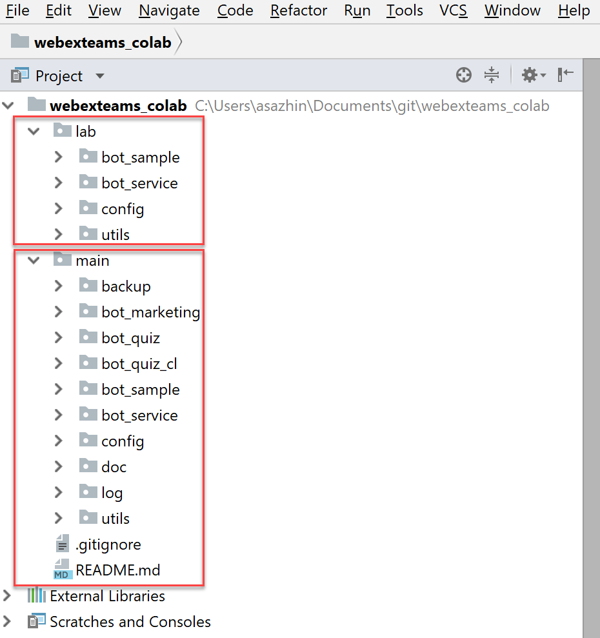

**Figure 17 - Project’s structure in PyCharm**

1. Prepare and test Python code to run Flask server to get Webhooks from Webex Teams Cloud

Open the following file: **lab > bot_sample > flask_sample.py**

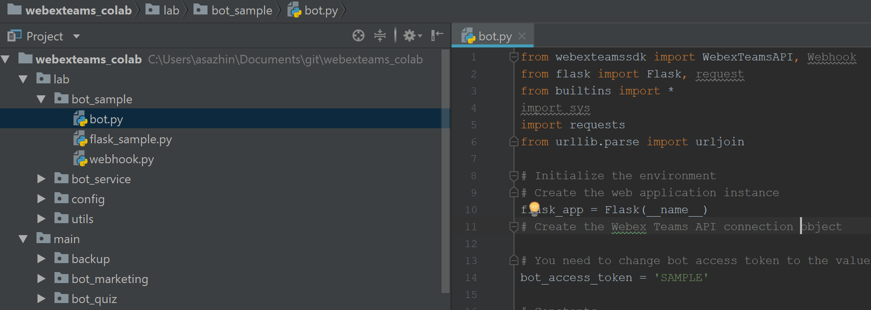

**Figure 18 – Sample bot’s project structure**

This file will be used to host a Python code to build and run web-server on Flask.

This web-server would be used in the next tasks to receive Webhooks from Webex Teams Cloud.

Below is the code to be used in this step:

|  |
| --- |
| **from** flask **import** Flask, request  # Initialize the environment  ngrok_port = 5000  # Create the web application instance flask_app = Flask(__name__)  @flask_app.route(**'/events'**, methods=[**'GET'**, **'POST'**]) |

**Snippet 1 – Flask initialization**

Code in more detailes:

1. First we imported the [**Flask**](http://flask.pocoo.org/docs/1.0/api/#flask.Flask) class. An instance of this class (**flask_app**) will be our Web Server Gateway Interface application
2. We then use the [**route()**](http://flask.pocoo.org/docs/1.0/api/#flask.Flask.route) decorator to tell Flask what URL should trigger the function **webex_teams_webhook_events()** each time it gets HTTP GET or POST[7]. This function will only trigger in case /events URI is accessed on Flask Web Server.
3. Ngrok_port would be used as port on which Flask web-server would be listening (static TCP port 5000 to be used in this case):

Below is a logic of **webex_teams_webhook_events()** function, that triggers each time it gets HTTP GET requests to the ‘/events’ URI.

This function returns a simple web page with Markdown as a lightweight markup language (used by Cisco Webex Teams). This simple web-page will show “Sample Bot running Flask” message in a web-browser:

|  |
| --- |
| def webex_teams_webhook_events():  *"""Processes incoming requests to the '/events' URI."""* if request.method == 'GET':  return ("""<!DOCTYPE html><html lang="en">  <head><meta charset="UTF-8"><title>ServiceBot</title></head>  <body>  <p><strong>Sample Bot running Flask</strong></p>  </body>  </html>""")   return 'OK' |

**Snippet 2 – Code to process incoming GET requests to Flask**

Below is the code to Start Flask Web server if this is main Python module.

|  |
| --- |
| if __name__ == '__main__':  *# Start the Flask web server* flask_app.run(host='0.0.0.0', port=ngrok_port) |

**Snippet 3 – Code to start Flask server**

Copy code from the previous snippets (1 to 3) and paste to **flask_sample.py** file, then run it and try to access using the Flask server, using the following URL: <http://127.0.0.1:5000/events>

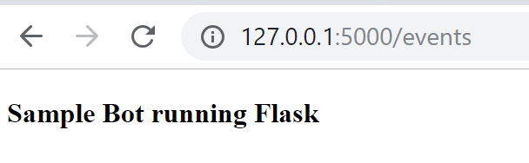

**Figure 19 – Sample Bot running on Flask**

1. Start Ngrok

See Chapter “Start Ngrok**”** in Option #1 for the details.

1. Prepare and test Python code to create a Webhook, pointing to forwarding URL created by Ngrok

Open the following file: **lab > bot_sample > webhook.py**

This file will be used to host a Python code to register a new Webhook.

Webhook is created automatically, based on forwarding URL created by Ngrok.

Below is the code to be used in this task:

|  |
| --- |
| **from** builtins **import** *  **from** webexteamssdk **import** WebexTeamsAPI **import** requests **from** urllib.parse **import** urljoin  # You need to change bot access token to the value provided by Pinacolada bot  **bot_access_token = 'SAMPLE'**  *# Constants* NGROK_CLIENT_API_BASE_URL = **"http://localhost:4040/api"** WEBHOOK_NAME = **"webhook_samplebot"** WEBHOOK_URL_SUFFIX = **"/events"** WEBHOOK_RESOURCE = **"messages"** WEBHOOK_EVENT = **"created"  try**:  **assert**(bot_access_token!=**'SAMPLE'**) **except** AssertionError:  print(**'Fatal: Please change \'bot_access_token\' variable in bot.py to the value provided by Pinacolada bot'**)  exit(-1) |

**Snippet 4 - webhook.py initialization part**

Paste snippet shown above to the **webhook.py** and place it under **#<put import and initialization values>** flag**.**

The first snippet contains code for the initialization of Webhook:

After **bot_access_token:** put **Bot’s Access Token** received from **PinaColada@sparkbot.io** bot earlier.

Have a look at the constants in this snippet, they are further used in the code and understanding of them is very important. Below is their meaning:

1. NGROK_CLIENT_API_BASE_URL – used in the API calls to Ngrok application to get the list of running tunnels (each instance of Ngrok starts two tunnels: for http and https[8]).
2. WEBHOOK_NAME – used to specify ‘name’ webhook request parameter. This is used as a label to remember why it was created. Used in the lab to distinguish between different bots.
3. WEBHOOK_RESOURCE – used to specify name of ‘resource’ webhook request parameter (**messages**).
4. WEBHOOK_EVENT – used to specify name of ‘events’ webhook should monitor (**created**).

Since we are only focusing on the messages posted to a room space with bot, resource = messages and type of event = created are the only things the Webhook have to subscribe to.

You can check out all possible supported combinations of resources and events in “Resources, Events & Filters” chapter in the documentation:

<https://developer.webex.com/docs/api/guides/webhooks>

1. WEBHOOK_URL_SUFFIX – used to add /events suffix to the URI generated automatically by Ngrok (Flask is listening on this URI).

The following functions are pre-built in **webhook.py** file:

1. get_ngrok_public_url() - Connects to an Ngrok management interface via API (http://localhost:4040/api

/tunnels), represents answer in JSON format, providing list of forwarding URLs (tunnels) provided by Ngrok.

1. get_ngrok_port - Connects to an Ngrok management interface via API (http://localhost:4040/api

/tunnels), represents answer in JSON format, providing port which is used by Flask web-server (Ngrok forwards all HTTP requests coming to this port on Flask)

1. delete_webhooks_with_name - Connects to Webex Teams API to check whether there is Webhook with the same name (uses WEBHOOK_NAME constant), if so, deletes it and creates new.
2. create_ngrok_webhook(api, ngrok_public_url, WEBHOOK_NAME) - Connects to Webex Teams API to create a new Webhook with parameters specified.
3. create_webhook – Invokes another functions (delete_webhooks_with_name, get_ngrok_public_url(), and, finally, reate_ngrok_webhook) to create Webhook.

Invoke create_webhook(api,WEBHOOK_NAME) function to create a Webhook in **webhook.py**:

|  |
| --- |
| **if** __name__ == **"__main__"**:  api = WebexTeamsAPI(bot_access_token)   **"""Delete previous webhooks. If local ngrok tunnel, create a webhook."""  if** create_webhook(api,WEBHOOK_NAME):  ngrok_port = get_ngrok_port()   **else**:  print(**'Can\'t create webhook for WebexTeams'**) |

**Snippet 5 – Webhook creation**

Paste snippet shown above to the **webhook.py** and place it under **#<put code running in main module here>** flag**.**

Run module **webhook.py** in PyCharm:

1. Open a Windows command line where **Ngrok** is running).
2. Ensure information about created Webhook is printed in **PyCharm**. Check hostname in “targetURL” that script is printing is the same as shown in **Ngrok** (compare “1” on **Figure 20** and “2” and“3” on **Figure 21** below).
3. Check that Error message: “Can't create webhook for WebexTeams” is **not** printed and there is a message: “Webhook successfully created” (see “4” on **Figure 21** below).

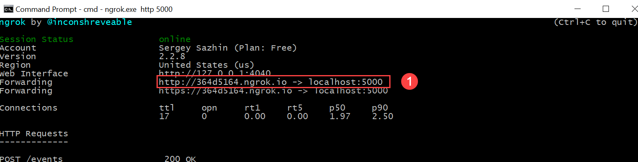

**Figure 20 – Forwarding URL Ngrok is hosting**

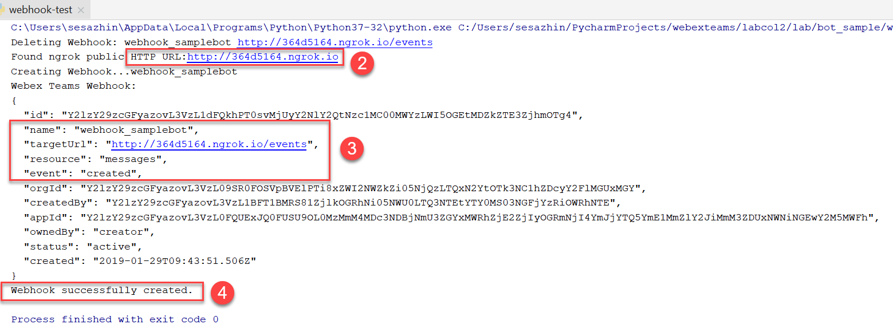

**Figure 21 – Output of webhook.py in PyCharm**

Before proceeding to the next Step, please ensure the scripts developed on the previous Steps are not running, otherwise, stop their execution on PyCharm:

* **flask_sample.py**
* **webhook.py**

1. Prepare and test Python code for core Sample’s bot functionality

Ensure that flask_sample.py and webhook.py was stopped, before proceed further:

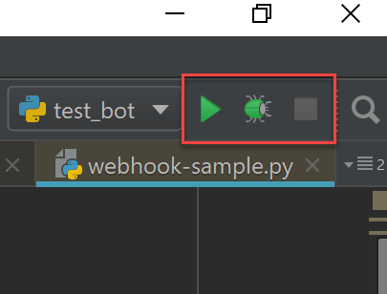

**Figure 22 - No running tasks in PyCharm**

Open the following file: **lab > bot_sample > bot.py** in PyCharm.

This is core logic of the bot, thus, it’s crucial to understand the functionality in more details. Description of the logic follows below:

1. **if** request.method == **'GET'**: - this check isn’t actually used with Webex Teams bots because Flask Web-server is only used to get Webhooks which are HTTP posts, not GETs. The part of code is only used so that you can check Flask is running successfully by connecting to http://127.0.0.1:5000/events - URI Flask is listening to.
2. **elif** request.method == **'POST'**: - this check is used to react on HTTP POST requests (Webhooks).
3. The following code you would see in any Webex Teams bot’s code receiveing messages from Webex Teams Cloud.

This is very important loop prevention mechanism. Otherwise the bot will enter an infinite loop after it sends message to Webex Teams room:

me = api.people.me()  
 **if** message.personId == me.id:  
 # Message was sent by me (bot); do not respond.  
 **return 'OK'  
  
 else**:  
 # Message was sent by someone else; parse message and respond.

For simplicity, print function is only used for logging purposes in this task. In later tasks you will be using logging module (Python builtin) for doing this.

1. In case a message wasn’t sent from bot, trigger comparison of the received command with **/echo** and **/whoami** patterns:

**if** message.text.lower().startswith(**"/echo "**):

**elif** message.text.lower() == **"/whoami"**:

1. In case one of the patterns mentioned above aren’t found – send a message back to a user showing what supported commands are (in a real-life scenario this message would also be present in /help directive in bot’s logic but in this task it’s omitted for the clarity).
2. Since email addresses of users are strored in a list, we are using for cycle to show all email addresses related to this user (**for** email **in** person.emails).

Below is code’s snippet for core logic of sample bot.

Paste snippet below to the bot.py file, under **#<put code for main business logic of the bot here>** flag.

# Core bot functionality  
# Your Webex Teams webhook should point to http://<serverip>:5000/events  
@flask_app.route(**'/events'**, methods=[**'GET'**, **'POST'**])  
**def** webex_teams_webhook_events():  
 """Processes incoming requests to the '/events' URI."""  
  
 **if** request.method == **'GET'**:  
 **return** (**"""<!DOCTYPE html><html lang="en">  
 <head><meta charset="UTF-8"><title>ServiceBot</title></head>  
 <body>  
 <p><strong>ServiceBot</strong></p>  
 </body>  
 </html>"""**)  
 **elif** request.method == **'POST'**:  
 **"""Respond to inbound webhook JSON HTTP POST from Webex Teams."""** # Get the POST data sent from Webex Teams  
 json_data = request.json  
 print(**"\n"**)  
 print(**"WEBHOOK POST RECEIVED:"**)  
 print(json_data)  
 print(**"\n"**)  
  
 # Create a Webhook object from the JSON data  
 webhook_obj = Webhook(json_data)  
 # Get the room details  
 room = api.rooms.get(webhook_obj.data.roomId)  
 # Get the message details  
 message = api.messages.get(webhook_obj.data.id)  
 # Get the sender's details  
 person = api.people.get(message.personId)  
  
 print(**"NEW MESSAGE IN ROOM '{}'"**.format(room.title))  
 print(**"FROM '{}'"**.format(person.displayName))  
 print(**"MESSAGE '{}'\n"**.format(message.text))  
  
 # This is a VERY IMPORTANT loop prevention control step.  
 # If you respond to all messages... You will respond to the messages  
 # that the bot posts and thereby create a loop condition.  
 me = api.people.me()  
 **if** message.personId == me.id:  
 # Message was sent by me (bot); do not respond.  
 **return 'OK'  
  
 else**:  
 # Message was sent by someone else; parse message and respond.  
  
 **if** message.text.lower().startswith(**"/echo "**):  
 api_response = **'Echoing back to you: {}'**.format(message.text[6:])  
 api.messages.create(room.id, text=api_response)  
  
 **elif** message.text.lower() == **"/whoami"**:  
 api_response = **'I know who you are:\n'** \  
 **'room_name = {}\n'** \  
 **'your First Name = {}\n'** \  
 **'your Last Name = {}\n'** \  
 **''**.format(room.title, person.firstName, person.lastName, person.emails)  
  
 print(**"SENDING RESPONSE TO A CLIENT '{}'"**.format(message.personId))  
 # Post the response to the room where the request was received  
 api.messages.create(room.id, text=api_response)  
  
 **for** email **in** person.emails:  
 #print("email = {}".format(email))  
 api_response = **"email = {}"**.format(email)  
 api.messages.create(room.id, text=api_response)  
  
 **else**:  
 api_response = **'The command you\'ve sent isn\'t supported! \n'** \  
 **'List of supported commands:\n'** \  
 **'1. /whoami - shows detailed info about you\n'** \  
 **'2. /echo [text] - echoes back [text] that you sent to me\n'** api.messages.create(room.id, text=api_response)  
  
 **return 'OK'**

**Snippet 6 – Core functionality of sample bot**

1. Test sample bot

* Run module **bot.py** from PyCharm.
* Get the bot’s name from bot **PinaColada@sparkbot.io.**
* Add the bot with the name **<XX>_CLEUR_LABCOL2293_<NUMBER>@webex.bot** in Webex Teams application.
* In the created room space, start conversation with bot:
  + If you input **/whoami** command, a bot will show an information about your account in Webex Teams.
  + If you input **/echo** followed with some phrase, the bot echoes the phrase back in the same Webex Teams room.
  + Try to ‘break’ the bot and check that it sustains your attempts and behaves correctly.

Possible data to input in a chat with a bot:

<phrase> **/whoami** <phrase>

**/whoami**<phrase>

**/whoami** <phrase>

**/whoami** <gif file>

**/whoami** <smile>

After you finish, go back to the **bot.py** and ensure you understand the core logic of a sample bot.

* 1. Create Cisco Support API bot (defect’s information)

In previous task you already created simple bot wih monolithic code design. All functions were mixed in one Python file except of webhook functions which were already separated. Let’s look into the design in more holistic way. We have several independent components which comprises a solution (see **Figure 23**):

**Web server** - used to receive events coming from WebEx cloud Ngrok tunnel can use used to speed up development when web server is behind filrewall.

**Bot** – command interpretor and processor. Performs message processing, command validation, data extraction.

**Business logic** – code which executes specific commands required by business template, returns message which needs to be returned to command sender

**Data source layer** – if business logic requires persistent data storage it’s implemented in separate layer to abstract and isolate specific data source from business logic



**Figure 23 - High-level diagram of bot’s logic and components**

Such decomposition and isolation allows you to build/replace separate blocks of code as your project grows. For example, you can move from Flask in development environment to another WSGI server or Nginx, implement load balancing and redundancy which keeping other component untouched. You can also extend number of platforms you run business logic on to Jabber, Telegram or Web Chat.

To complete this task, the following steps have to be followed:

1. Prepare common components
   1. Use code of Service Bot from GitHub project.
   2. Replace Bot’s Access Token in a configuration of a bot.
   3. Start Ngrok.
   4. Run Web Server and verify it accessible locally and over ngrok tunnel.
2. Create bot functions in bot.py file
3. Create business layer functions bi_template.py
4. Start Service Bot and verify that you can get bug description from it Cisco Cloud
5. Use code of Service bot from GitHub.

Pull Webex Teams bot’s code from GitHub (See Chapter “Copy code of sample bot from GitHub” from Option #1 for the details).

Bot for the current task is located in folder: **/lab/bot_service/**

After copying of the code from GitHub is completed, you will see a project’s structure in a Project’s tab on the left-side of PyCharm.

In a PyCharm check Project’s structure (see **Figure 24**):

**lab** – contains the files with Python code. You will paste a code to the files in this directory doing the lab.

**main** – contains the files with completely working Python code. The structure of this directory is the same as **lab** directory. You can refer to the files in this directory if you have any problems while doing the tasks.



**Figure 24 - Project’s structure in PyCharm**

1. Replace Bot's Access Token in a configuration of a bot

In a PyCharm, open a bot’s configuration file:

**lab > config > config_service.yml**

In config_service.yml file, after **bot_access_token:** put **Bot’s Access Token** received from **PinaColada@sparkbot.io** bot earlier.

1. Start Ngrok

Start Ngrok application (See “Start Ngrok” in Step 2 of Option #1).

1. Run Web Server and verify it accessible locally and over ngrok tunnel.

server.py file will contain web server code. It already contains relevant imports and generic code for config processing and logging.

Import standard function ***process_message*** for incoming message processing from **bot.py**. We will create this function later

|  |
| --- |
| # import process_message function from bot code as scvbot_process_message # you can later run multiple bots on same web server under different API points **from** bot **import** process_message **as** svcbot_process_message |

**Snippet 7 – import process_message to server.py**

Paste snippet above to the **server.py** under **#<put import process_message>** flag**.**

Create new Flask application to host web server.

|  |
| --- |
| # Create the web application instance flask_app = Flask(__name__) |

**Snippet 8 – Create Flask application instance**

Paste snippet above to the **server.py** under **#<create flask instance>** flag**.**

Define function ***webex_teams_webhook_events*** which will be processing HTTP requests.

|  |
| --- |
| # Define route in Flask to send requests coming to /events API point to function webex_teams_webhook_events() # Your WebEx Teams webhook should point to http://<serverip>:<port>/events # Allow GET and POST message processing @flask_app.route(**'/events'**, methods=[**'GET'**, **'POST'**]) **def** webex_teams_webhook_events():  """Processes incoming requests to the '/events' URI."""  **if** request.method == **'GET'**:  **return** (**"""<!DOCTYPE html><html lang="en">  <head><meta charset="UTF-8"><title>ServiceBot</title></head>  <body>  <p><strong>ServiceBot</strong></p>  </body>  </html>"""**)  **elif** request.method == **'POST'**:  **"""Responds to inbound webhook JSON HTTP POST from Webex Teams."""** # Log POST data sent from Webex Teams  logging.info(**'WEBHOOK POST RECEIVED:'**)  logging.info(request.json)  # Send incoming message in json format to bot layer and return as results  **return** svcbot_process_message(api,request.json) |

**Snippet 9 – Create webex_teams_webhook_events function**

Paste snippet above to the **server.py** under **#<create webhook events>** flag**.**

Create main function:

|  |
| --- |
| **if** __name__ == **'__main__'**:  logger.info(**f'Start using token:{config["bot_access_token"]}'**)  api = WebexTeamsAPI(config[**'bot_access_token'**])  webhook_name = config[**'webhook_name'**]   **"""Delete previous webhooks. If local ngrok tunnel, create a webhook."""  if** webhook.create_webhook(api,config[**'webhook_name'**]):  ngrok_port = webhook.get_ngrok_port()  logger.info(**f'Get ngrok port={ngrok_port}.Starting Flask server on it'**)   *# Start the Flask web server* flask_app.run(host=**'0.0.0.0'**, port=ngrok_port)  **else**:  logger.fatal(**'Can\'t create webhook for WebexTeams'**) |

**Snippet 10 – main function creation**

Paste snippet above to the **server.py** under **#<create main function>** flag**.**

First call in main function is to create webhook. Take a note that values for ‘webhook_name’ and ‘access_token’ variables are taken from the configuration file, that is loaded using following assignment:

config = setinitial.setup_config('config/config_service.yml')

Reading variables from the file is considered to be the good practice, since you can reference the value located in the single location across different parts of the code.

Run **server.py** from PyCharm.

1. Ngrok verification

As you already checked in the previous task Flask should reply to GET request from browser.

Verify that ngrok tunnel is working by going to <http://localhost:4040/status> and checking current dynamic URL of **Ngrok**.

You should see output similar to the below screenshot. Make sure Tunnel status is **online**:

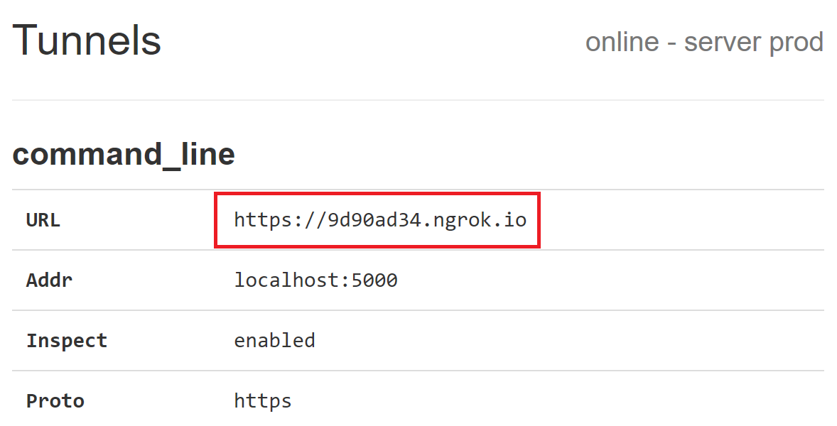

**Figure 25 – Check status of tunnel in Ngrok**

Now open new tab in Chrome and access **Ngrok** tunnel URL and you should see ServiceBot web page:

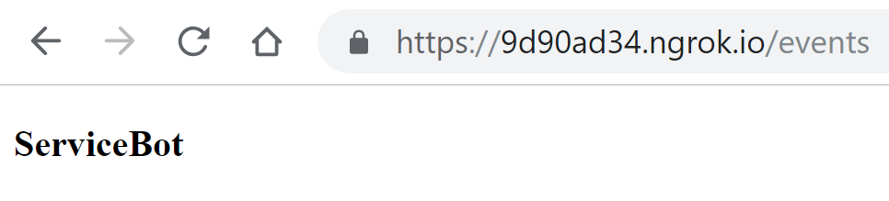

**Figure 26 – Check Flask is running and Ngtok URL works**

Stop execution of **server.py** from PyCharm.

1. Create bot functions in bot.py file

|  |
| --- |
| **def** process_message(api: WebexTeamsAPI,json_data):  *# Create a Webhook object from the JSON data* webhook_obj = Webhook(json_data)  *# Get the room details* room = api.rooms.get(webhook_obj.data.roomId)  *# Get the message details* message = api.messages.get(webhook_obj.data.id)  *# Get the sender's details* person = api.people.get(message.personId) |

**Snippet 11 – process_message function creation**

Replace function **process_message** in bot.py with new content from the snippet above.

Above we are extracting from json request 3 important elements of WebEx Teams cloud to be able to identify sender, room and get the message itself: person, room and message.

As a best practice all interactions with external entities should be logged as much as possible for easier troubleshooting.

|  |
| --- |
| logger.info("NEW MESSAGE IN ROOM '{}'".format(room.title))  logger.info("FROM '{}'".format(person.displayName))  logger.info("MESSAGE '{}'\n".format(message.text)) |

**Snippet 12 - process_message logging**

Paste snippet above to the **bot.py** under **#<process_message function2>** flag**.**

Below code represents important loop prevention control step. If you respond to all messages here bot will respond to its own messages that it sent and by that create a loop. Here we are filtering messages that were originated bot.

|  |
| --- |
| me = api.people.me()  **if** message.personId == me.id:  *# Message was sent by me (bot); do not respond.* **return 'OK'** |

**Snippet 13 - process_message loop prevention**

Paste snippet above to the **bot.py** under **#<process_message function3>** flag**.**

If message was sent by another user we know it should be one of the commands that is supported by the bot. As part of decomposition and isolation design we are building abstract command processing function **process_command**. For that we proceed with following steps:

* create dict from important identity parameters
* pass this dict to generic message function
* function returns list of replies that needs to be sent back to user

**else**:  
 *# Message was sent by someone else; parse message and respond.* params = dict()  
 params[**'person'**] = person  
 params[**'room'**] = room  
 params[**'message'**] = message  
 results = process_command(params)  
 **for** result **in** results:  
 *# Post the response to the room where the request was received* api.messages.create(room.id, markdown=result)  
 **return 'OK'**

**Snippet 14 - process_message message parsing**

Paste snippet above to the **bot.py** under **#<process_message function4>** flag**.**

The most interesting function is **process_command** as it abstracts bot layer from business logic.

|  |
| --- |
| **def** process_command(params):  command = params[**'message'**].text.lower().split()[0]  **if** command[0] == **'/' and f'cmd_{**command[1:]**}' in** globals():  **return** globals()[**f'cmd_{**command[1:]**}'**](params)  **elif 'cmd_default' in** globals():  **return** globals()[**'cmd_default'**](params)  **else**:  **return** [**'Invalid command. Please use /help for list of commands.'**] |

**Snippet 15 - process_command function creation**

Paste snippet above to the **bot.py** under **#<process_command main function>** flag**.**

By using **globals()** call we can get all functions defined in the current code. By naming separate command processing functions as ***cmd_<command name>*** we can enable automatic discovery and execution of commands.

There is a default command which can be defined and returned if no specific function exists to process command sent by the user. Otherwire we will get **Invalid command. Please use /help for list of commands.**

That’s it for the bot layer in the lab. On practice this layer is responsible for reliable delivery of the messages, bot redundancy operations and cloud error processing.

1. Create business layer functions in bi_template.py

Open **bi_template.py** in PyCharm.

|  |
| --- |
| **def** cmd_bug(params):  *"""**/bug <defect>** - return information for defect"""* logger.info(**"FOUND '/bug'"**)  bug_id = params[**'message'**].text.split()[1].strip()  *# Get a response*  bug_headline, bug_description = get_bug_api(bug_id)  logger.info(**"SENDING RESPONSE FROM BUG API '{}'"**.format(bug_headline)) *# Post the response to the room where the request was received* results = list()  results.append(**'**'**+bug_id+**': '**+bug_headline+**'**'**)  results.append(**'- - -'**)  results.append(bug_description)  **return** results |

**Snippet 16 – cmd_bug function creation**

Paste snippet above to the **bi_template.py** under **#<cmd_bug function>** flag**.**

Every function which processing specific command should compy to following rules:

* function name comprised from ***‘cmd_ ‘*** followed by the bot command name
* start with doc string defining command format and description

Usually command processing functions will business function which performs required action and return message content which needs to be delivered back to the user.

Function **cmd_help** is of specific importance because it’s used to autogenerte bot commands help and any new command which complies with above requirements will be .

|  |
| --- |
| **def** cmd_help(params):  *"""**/help** - print list of supported commands"""* results = []  **for** obj **in** globals():  **if 'cmd_' in** obj **and** obj **is not 'cmd_default'**:  results.append(globals()[obj].__doc__)  **return** results |

**Snippet 17 - cmd_help function creation**

Paste snippet above to the **bi_template.py** under **#<cmd_help function>** flag**.**

It uses **globals()** dict which python is holding fir the current code and calls to docstring property to get the help.

1. Test Cisco Support API bot
   * Run module **server.py** from PyCharm.
   * Get the bot’s name from bot [**PinaColada@sparkbot.io**](mailto:PinaColada@sparkbot.io)**.**
   * Add the bot with the name **<XX>_CLEUR_LABCOL2293_<NUMBER>@webex.bot** the bot’s name in Webex Teams
   * In the created room space start conversation with bot:
     + If you input **/bug** <bug_id> commands, bot should return you description of the bug with requested bug id:
       - /bug CSCdr72939
       - /bug CSCvb57414
       - /bug CSCuz44968
     + If you input **/help** command, bot should return you list of supported command. Make a note, that the list of supported commands are generated automatically from the functions, that starts from ‘cmd_’ in file **bi_template.py**
     + Try to break the bot and check the results:
       - **/bug** test – this inappropriate bug id shold cause the bot to fail, because we don’t have any handling for non existed bug ids. Think how we can handle such situations, to improve stability.
2. Add another Support API handler

Check Support API documentation page and add handler for another API (EoX, Product Information or Software Suggestions)

<https://developer.cisco.com/docs/support-apis/#!automated-software-distribution>

Tip: as an example please take ***cmd_bug*** and ***get_bug_api*** function from **bi_template.py**.

Summary

The bots in various messengers are very popular nowadays, but sometimes lacking the business logic behind them, making the bots irrelevant to the real business cases.

To solve business needs, you need to focus not only on the WebexTeams API, but also on integration of bot's Python code with various external systems (JSON, email, PostgreSQL, Flask, Ngrok, etc).

These are the most important integrations and were examined and explained in this lab.

During this lab you’ve also got an understanding how bots for Webex Teams could be applied in a real world scenarious along with validated use-cases.

We hope this information was useful and you will use it in your job.

Happy programming and good luck with Webex Teams bots!

Please, don’t forget to rate the lab so that we can make it better.

Links to the LABCOL-2293 Project on GitHub

**URL to Clone or download:** <https://github.com/cleur2293/labcol.git>

**URL to open in a browser:** <https://github.com/cleur2293/labcol>

Up to date version of the code and lab guide are always available using these links. Fill free to use it in your Projects.

Related Sessions at Ciscolive

Extending the Collaboration Eco-System using Webex Teams APIs for Non-Developers - **BRKCOL-2175**.

Cognitive Collaboration – AI and Machine Learning Assisted Collaboration - **BRKCOL-1460**.

List of Acronyms

|  |  |
| --- | --- |
| **Acronym** | **Description** |
| EoX | End of support |
| IDE | Integrated Development Environment |
| JSON | JavaScript Object Notation |
| RDP | Remote Desktop |
| SMTP | Simple Mail Transfer Protocol |

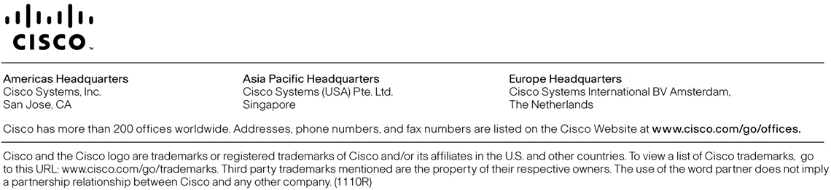

1. Press **Start** andput **mstsc** in search field to find Microsoft Remote Desktop application.
2. Use credentials from your lab ticket or from lab proctor.
3. Python 3.8.1 release.
4. Use credentials from your lab ticket or from lab proctor.
5. For the example shown above on **Figure 7** the TargeURL is: **http://aed6d6ef.ngrok.io/events**
6. Access token for bot **CLEUR_LABCOL2293_<random 3-digits number>@webex.bot** created in a previous steps.
7. In the current task only HTTP GET requests would be handled by Flask.
8. You can check them as well in Microsoft Windows CLI where Ngrok is running (**Figure 7**).